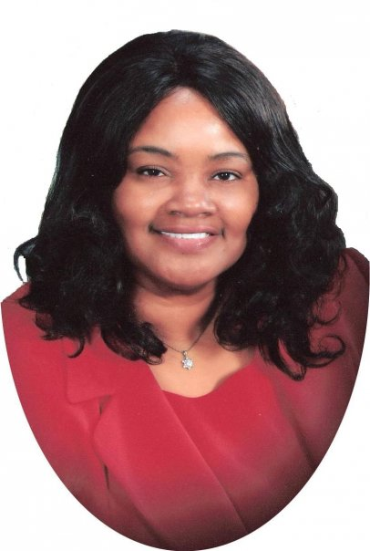
Dear Friend

I would like to take this moment to thank you for having an interest in helping me to reach the lost for Christ. I have a vision to go to the masses as never before.

I look around me and see how time is moving so fast. I feel that there is much work yet to be done. It takes friends such as you to help me run with this vision and fulfill the call of God that is upon my life.

Every soul I win and every sick body that is healed you have a hand in it. To God be all the glory.

I am praying for you and I request that you pray for me. Where there is unity there is strength.

Covenant Partner let us join hands together to bring in a great harvest of souls.

Your Sister in Christ
Linda C. Shearrill
Today I make a commitment to join hands with Dr. Linda C. Shearrill in Covenant Partnership to help her Reach the World for Christ before the coming of our Lord. (Please Print)

Name_______________________________________________________

Address_____________________________________________________

City_____________________________ State/Province ________Zip/Postal Code__________

Country_______________________________________

My monthly comment is:

$25___ $50___ $100___ Other______________

Please clip and mail to: Linda C. Shearrill Ministries P.O. Box 440064 Chicago, IL 60644 USA
All donations are tax deductible through International Deliverance Outreach Ministries. Please make check or Money Order out to IDOM and mail today.

